English 645: Transnational Politics in Post-9/11 Fiction

Prof. Joseph Conte
Fall 2016
W 3:30-6:10
1032 Clemens Hall
Reg. #: 21048/49

Literature after September 11, 2001 reflects a shift from the provincial politics of nation-states to that of transnational politics—issues that require adjudication across national, geographic, cultural, linguistic, religious, and racial borders. In the epoch of globalization, these are conflicts that are unlikely to be resolved without the cooperation and understanding of diverse peoples willing to set aside sectarian interests. If the collapse of the Soviet Union in 1991 brought to a close an overt dichotomy in international politics and deprived Western writers of a reliable foil, the events of 9/11 not only redirected our “intelligence community” from counterespionage to counterterrorism but also compelled writers to attend to a multilateral political terrain beyond the nation-state. This new political paradigm is both transnational and asymmetrical. The system of global capitalism, for which the secular ideals of representative democracy are a thinly disguised “advance man,” contends with the emergent threat of a transnational theocracy that is resistant to the agnostic, graphical, and consumerist Western ideology.

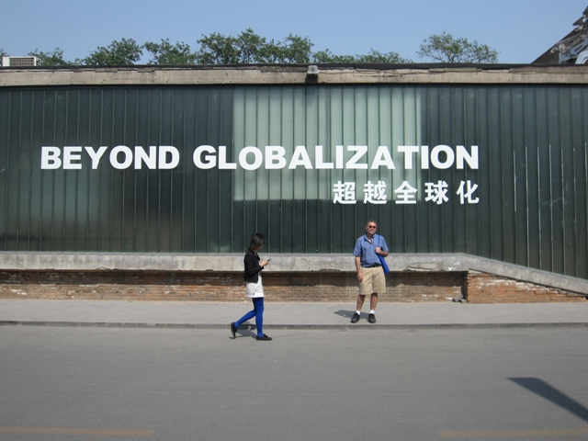
We will read some works of fiction that directly represent the events of 9/11 on American soil and others that reflect changes in the global political and cultural milieu in its aftermath. Native New Yorker Don DeLillo has called this the “age of terror” in his immediate response to the collapse of the towers, “In the Ruins of the Future: Reflections on Terror and Loss in the Shadow of September,” and in Falling Man (2007), he eschews documentary realism in favor of representing 9/11 through the cognitive and psychological trauma of a World Trade Center survivor whose recuperation is the beginning of a “counternarrative” to terrorism. Orhan Pamuk gauges the impact on the streets of Istanbul in “The Anger of the Damned,” but he sets his only political novel, Snow (2004), in the village of Kars in far eastern Turkey, away from the multiculturalism of Istanbul that links Europe and Asia, in order to foreground the tensions and resistance between Islam and Turkey’s secular state as girls, forbidden to wear head scarves to school, commit suicide. J. M. Coetzee, in Diary of a Bad Year (2007), fashions a multi-tracked narrative in which the author-surrogate Señor C. ventures a series of “strong opinions” on anarchism, terrorism, the state, Al Qaida, democracy and so on that question the purpose of writing in an ethically confused and disputatious world.

These and other works of contemporary fiction and nonfiction, in whole or in part—Paul Auster, Man in the Dark (2008), Jean Baudrillard, The Spirit of Terrorism (2002), Noam Chomsky, 9/11: Was There an Alternative? (2011), Mohsin Hamid, The Reluctant Fundamentalist (2007), Ken Kalfus, A Disorder Peculiar to the Country (2006), Joseph O’Neill’s Netherland (2008), Amy Waldman, The Submission (2011), Lawrence Wright, The Looming Tower (2006), and Slavoj Žižek, Welcome to the Desert of the Real (2002)—suggest that, rather than suffering from self-absorption and disaffection, innovative fictions have engaged global politics. As Pamuk contends, it is through novels that world citizens do their deepest thinking about themselves.

Course requirements include a seminar presentation and a twenty-page research paper that will integrate fiction and nonfiction, sociopolitical and literary critical sources.

