English 645: Multimodality in the Novel

Prof. Joseph Conte

Spring 2018
Reg. #: 23292
W 12:30 pm–3:10 pm

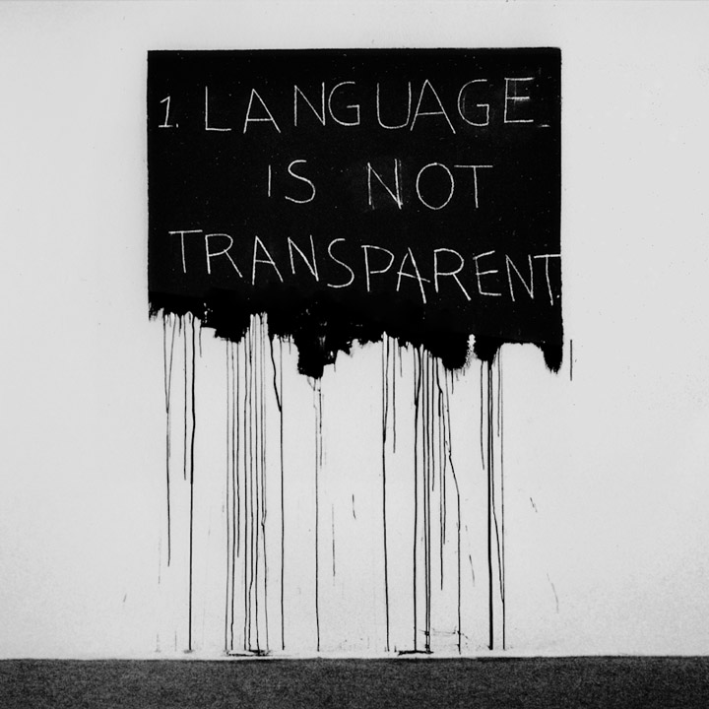
In this seminar on innovative fiction, we will examine the contraindicated persistence of multimodality in print novels; or, books you can’t read on a Kindle™. Alison Gibbons defines multimodality as “the coexistence of more than one semiotic mode within a given context.” We experience multimodality as the environment of our daily lives, in various platforms that include the urban streetscape, art galleries, digital “desktops” and other electronic media. Multimodality is as new as the iPhone X with its app icons and voice assistance, but as old as the New England Primer’s abecedarium. Multimodal literature may be regarded as both the resistance to and the appropriation of digital technology in the print medium. Most literary works are monomodal and language-centered; they call on the reader’s store of linguistic competency and comprehension of the symbolic mode, but they subordinate or exclude the iconic and indexical modes. Multimodal literature, however, exhibits polysemiosis: the reader encounters two or more semiotic modes and recognizes that they are not autonomous meaning systems but semantically interrelated. The experience of reading a multimodal text requires that the reader—in the broadest sense of the word—negotiate between systems of meaning, not merely within the rule of one mode. The relation between the verbal text, visual icon, and indexical design is one that is cognized rather than decoded. So the study and reception of multimodal literatures requires the development of a cognitive poetics.

Each of the multimodal books that we will peruse exhibits a “set” toward a dominant mode while retaining reference to all others: the book can trend toward a. transparency, or the set toward narrative, mimesis or character; b. opacity, or the set toward the form of the novel; c. code, or the set toward the visual appearance, the icon; or d. base, or the set toward the form of the book. We will want to examine the effects of multiple reading paths on narrative structure; the physical manipulation required to read one or more of these books; the relationship between the semiotic modes of the graphical and textual in all of these books; the “self-conscious” reading that is required by works that call attention to themselves as books; or the metafictive reflexivity of these works as fictions; etc.

Works for extended discussion may include: Mark Z. Danielewski, Only Revolutions (2006); Umberto Eco, The Mysterious Flame of Queen Loana: An Illustrated Novel (2004); Jonathan Safran Foer, Tree of Codes (2010); Alison Gibbons, Multimodality, Cognition, and Experimental Literature (2011); B. S. Johnson, The Unfortunates (rev. ed. 2009); Vladimir Nabokov, The Original of Laura (Dying is Fun) (2008); Tom Phillips, A Humument: A Treated Victorian Novel (5th ed. 2012); W. G. Sebald, Austerlitz (2001); Art Spiegelman, MetaMaus: A Look Inside a Modern Classic (2011); Steve Tomasula, VAS: An Opera in Flatland (2004); Chris Ware, Building Stories (2012); and Glyn White, Reading the Graphic Surface: The Presence of the Book in Prose Fiction (2005). Other literary and critical readings will be available through UB Learns or on graduate course reserve.

Course requirements will include a twenty-minute seminar presentation by all enrolled students and a twenty-page research paper from those students registered intensively.

